PRCE-001 Medical Data History

Task 1:-Pull docker image with SQL environment

**DAY-1**

* Pulled the official MySQL Docker image using docker pull mysql:latest.
* Created and started a MySQL container for the project and saved all setup steps in a folder named **medical_sql_project**.
* Configured the container with root credentials and port mapping as documented in the notepad file.





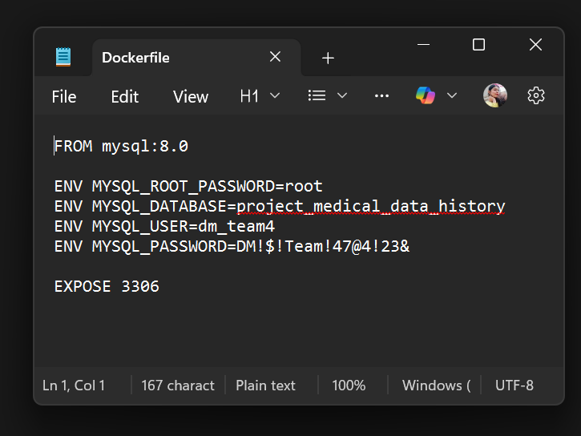

Task 2: Perform the Problem Queries:

**DAY-2**

**Performed 1 to 5 queries.**

1. Show first name, last name, and gender of patients whose gender is 'M'

use project_medical_data_history;

select first_name, last_name, gender from patients where gender = 'M';

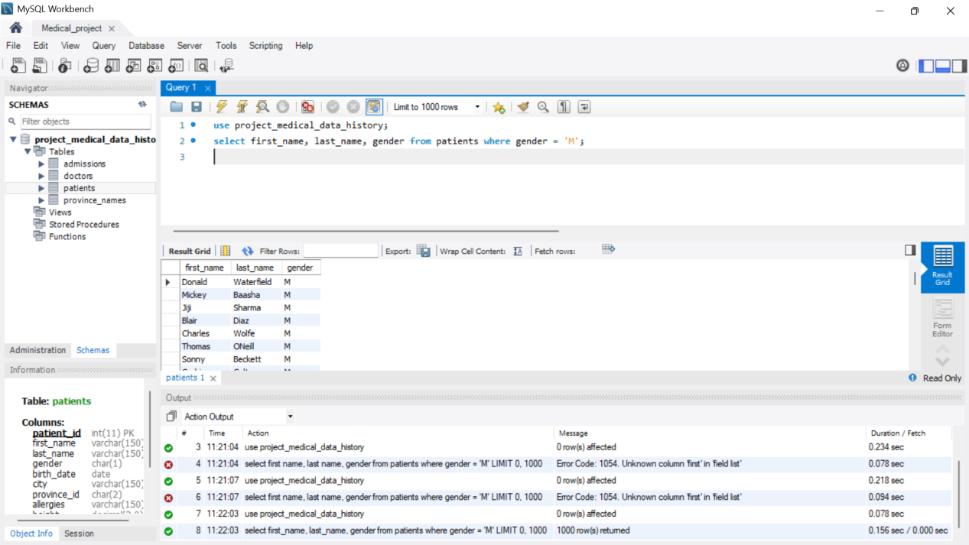

1. Show first name and last name of patients who do not have allergies.

select first_name, last_name from patients where allergies is null;

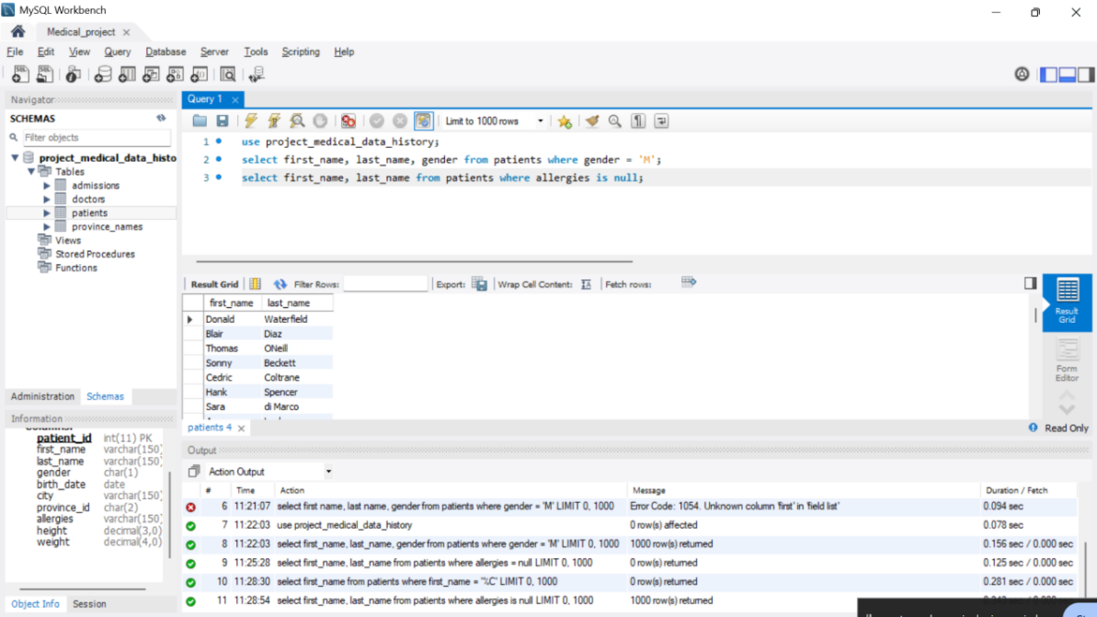

1. Show first name of patients that start with the letter 'C'

select first_name from patients where first_name like '%C';

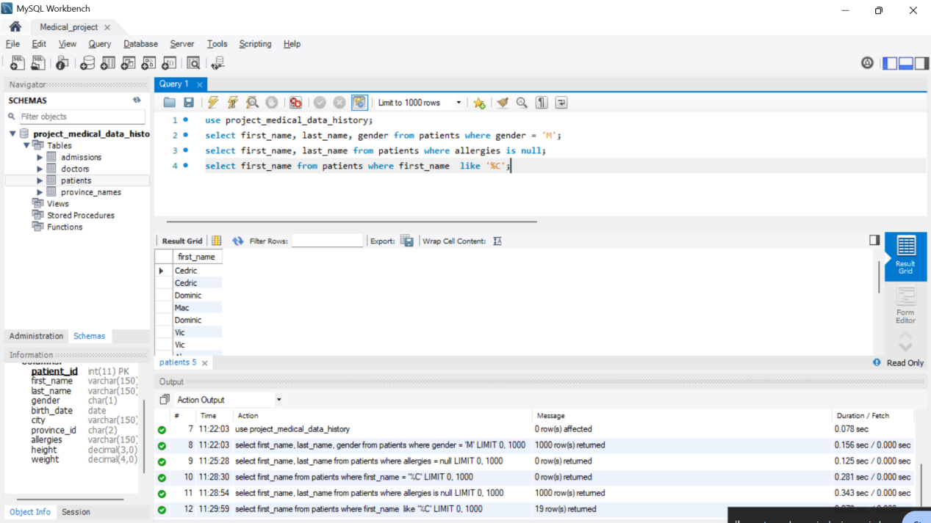

4. Show first name and last name of patients that weight within the range of

100 to 120 (inclusive)  
  
select first_name, last_name from patients where weight between 100 and 120;

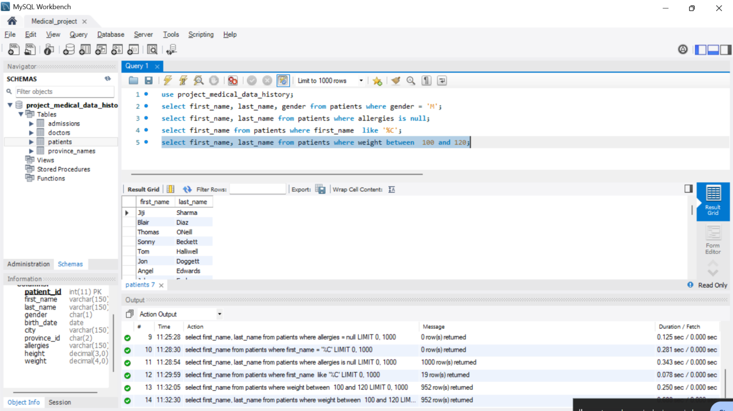

5. Update the patients table for the allergies column. If the patient's allergies is

null then replace it with 'NKA'

select patient_id, first_name,last_name, coalesce(allergies, 'NKA') as allergies from patients;

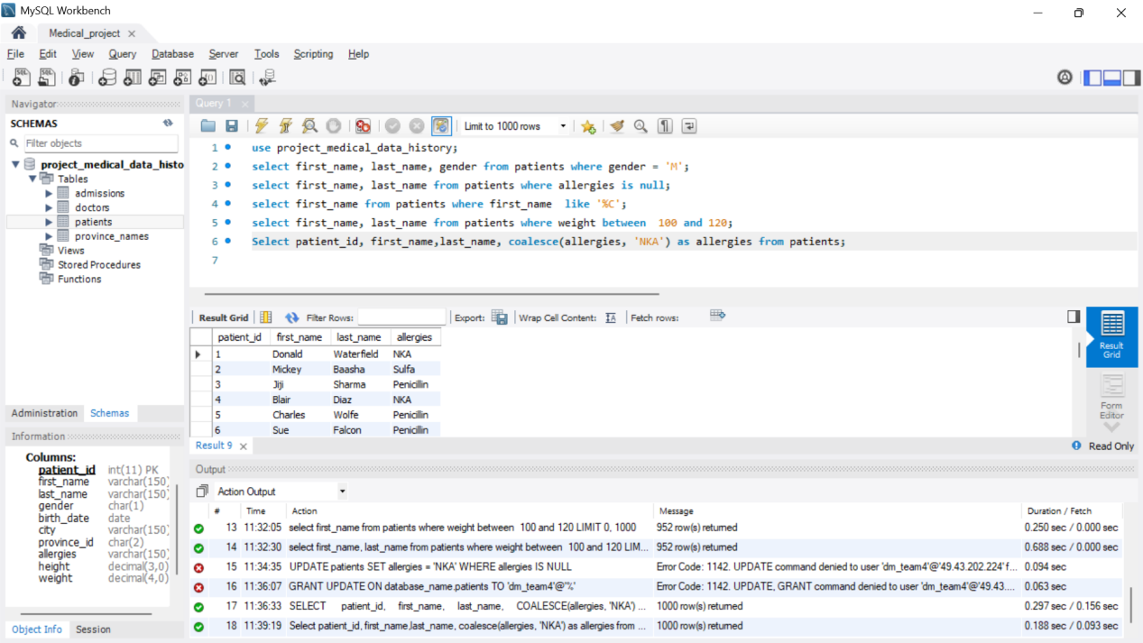

**DAY-3**

**Performed 6 to 10 queries.**

6. Show first name and last name concatenated into one column to show their

full name.

select concat(first_name, ' ' , last_name) as full_name from patients;

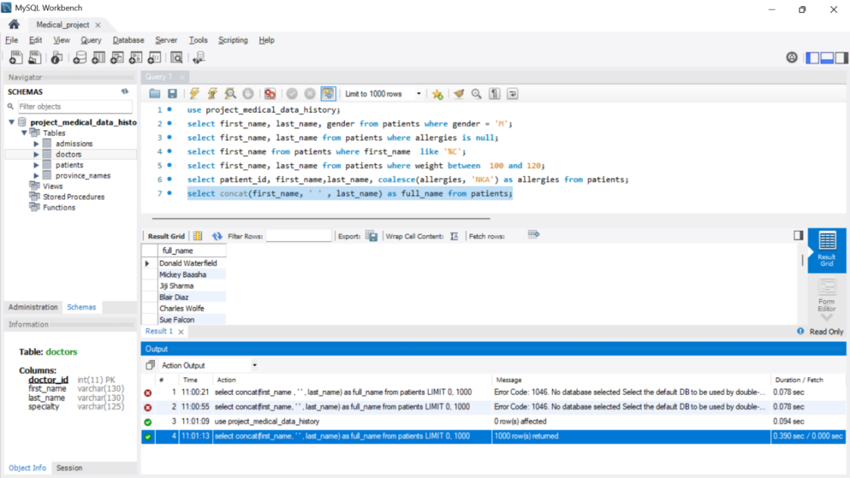

1. Show first name, last name, and the full province name of each patient.

select p.first_name, p.last_name, pr.province_name as full_province_name from patients p join province_names pr on p.province_id = pr.province_id;

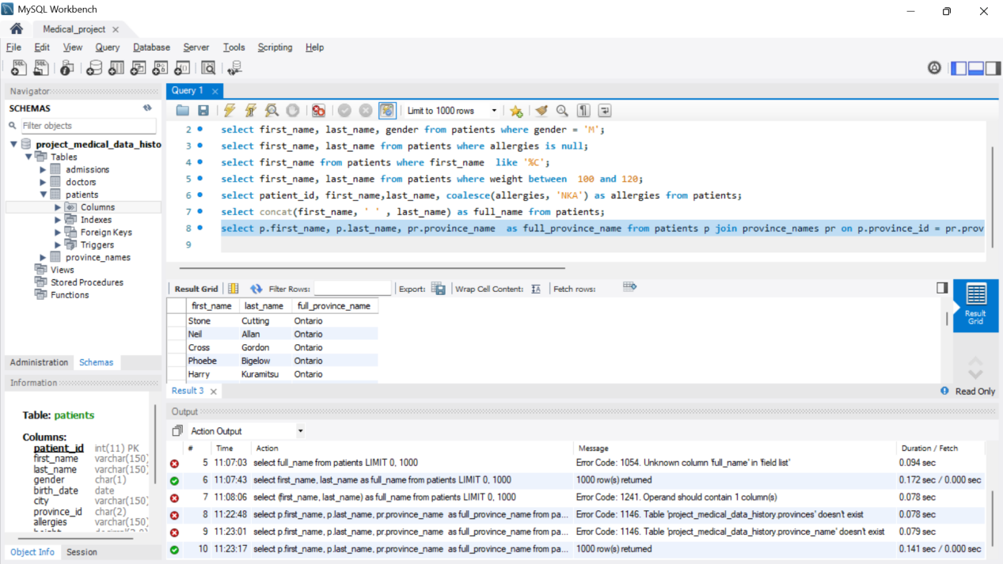

1. Show how many patients have a birth_date with 2010 as the birth year.

select count(*) from patients where year (birth_date) = 2010;

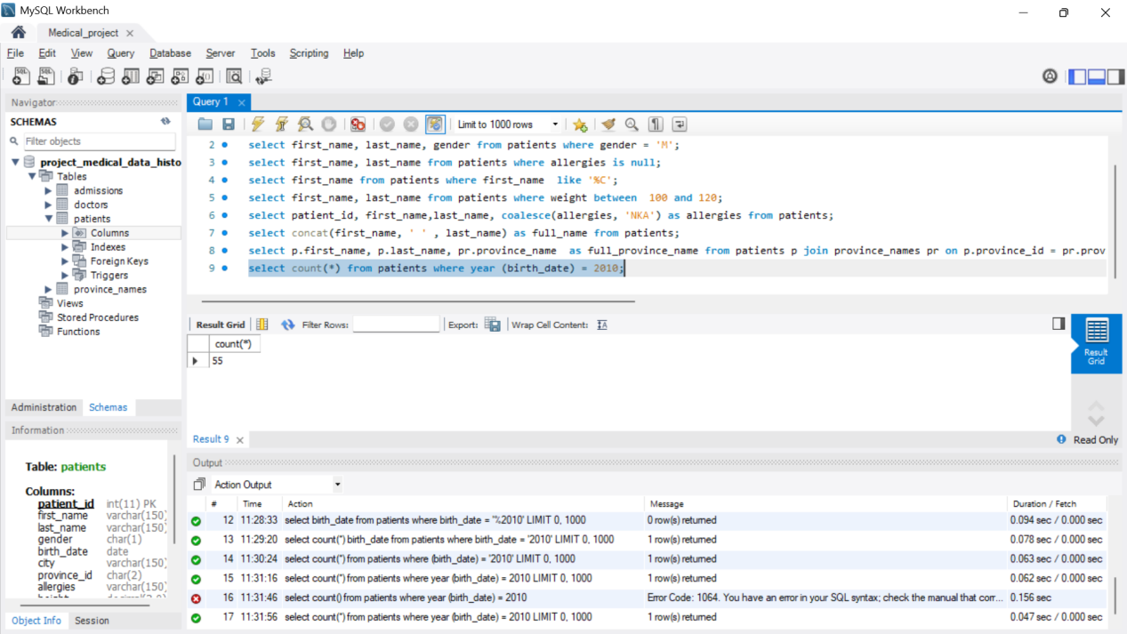

9. Show the first_name, last_name, and height of the patient with the greatest

height.

select first_name, last_name, height from patients order by height desc;

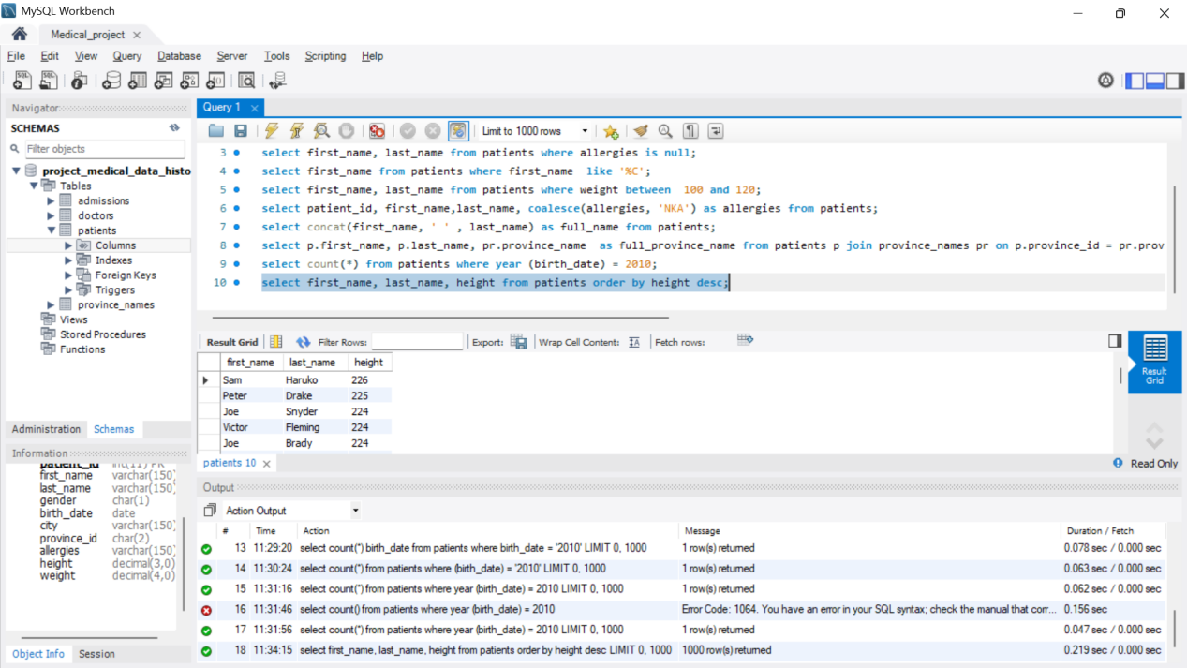

10. Show all columns for patients who have one of the following patient_ids:

1,45,534,879,1000.

select * from patients where patient_id in (1,45,534,879,1000);

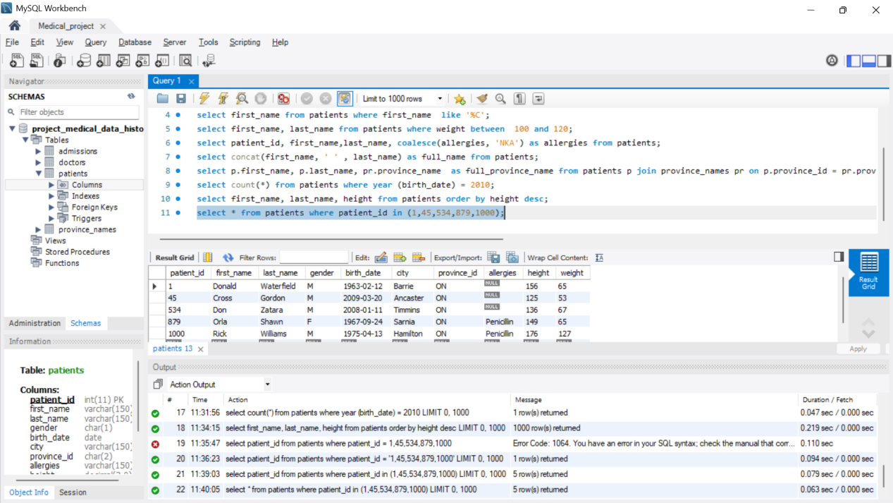

**DAY 4**

**Performed 11 to 20 queries.**

1. Show the total number of admissions

select count(*) from admissions;

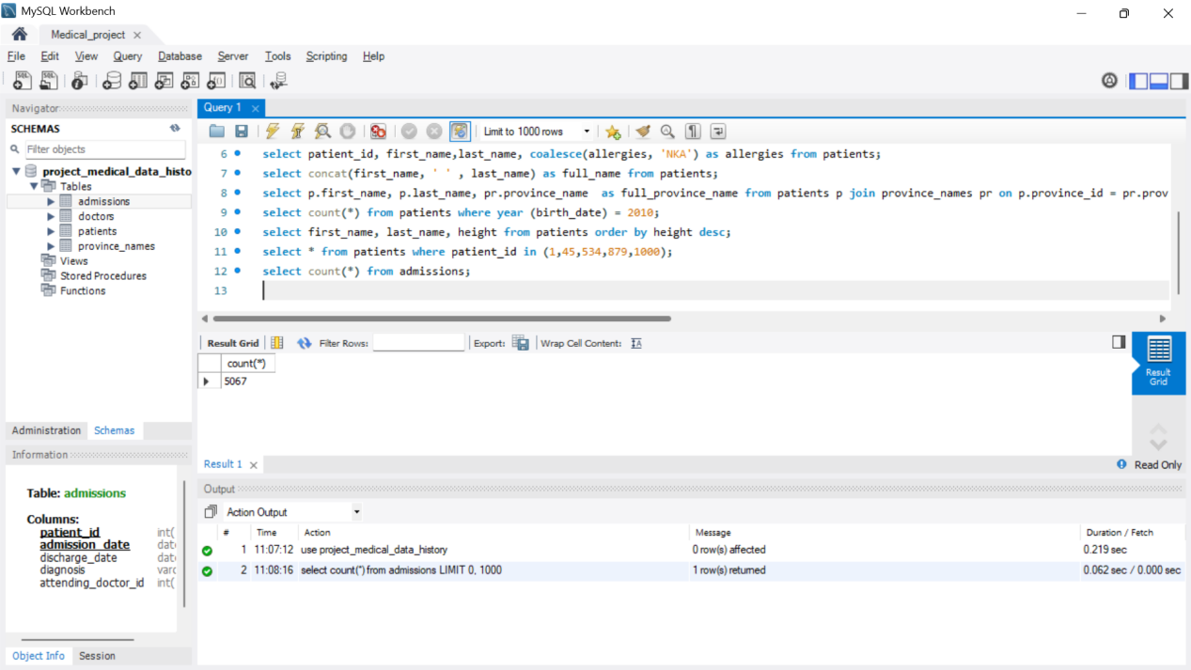

12. Show all the columns from admissions where the patient was admitted

and discharged on the same day.

select * from admissions where admission_date= discharge_date;

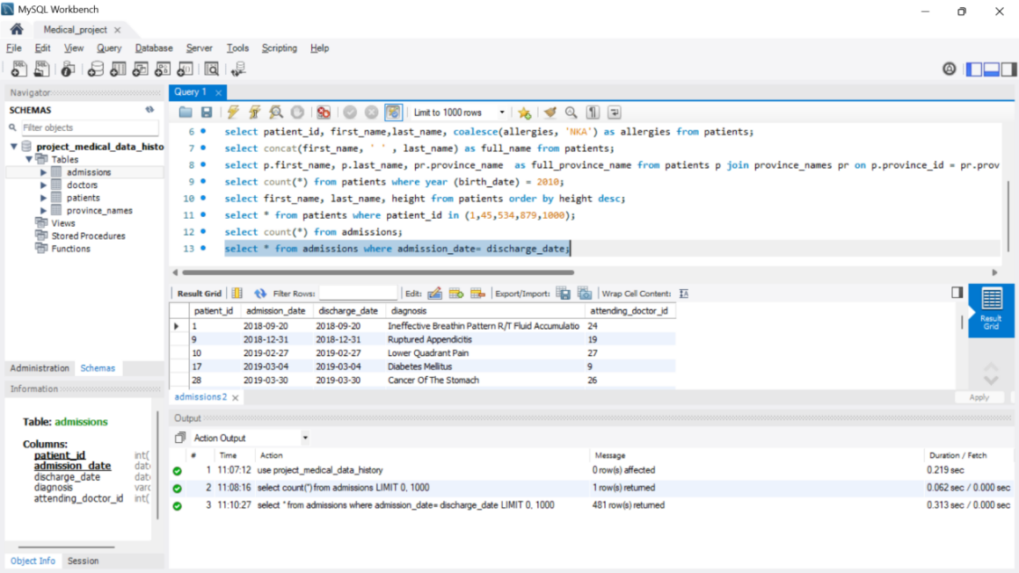

13. Show the total number of admissions for patient_id 579.

select admission_date from admissions where patient_id in (579);

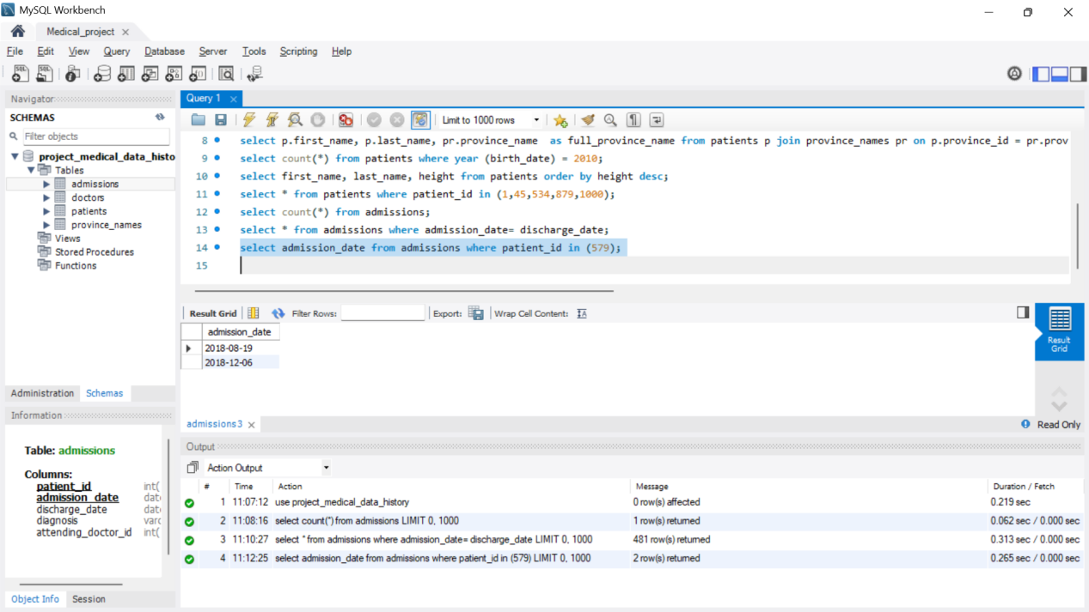

14. Based on the cities that our patients live in, show unique cities that are in

province_id 'NS'?

select distinct city from patients where province_id = ('NS') ;

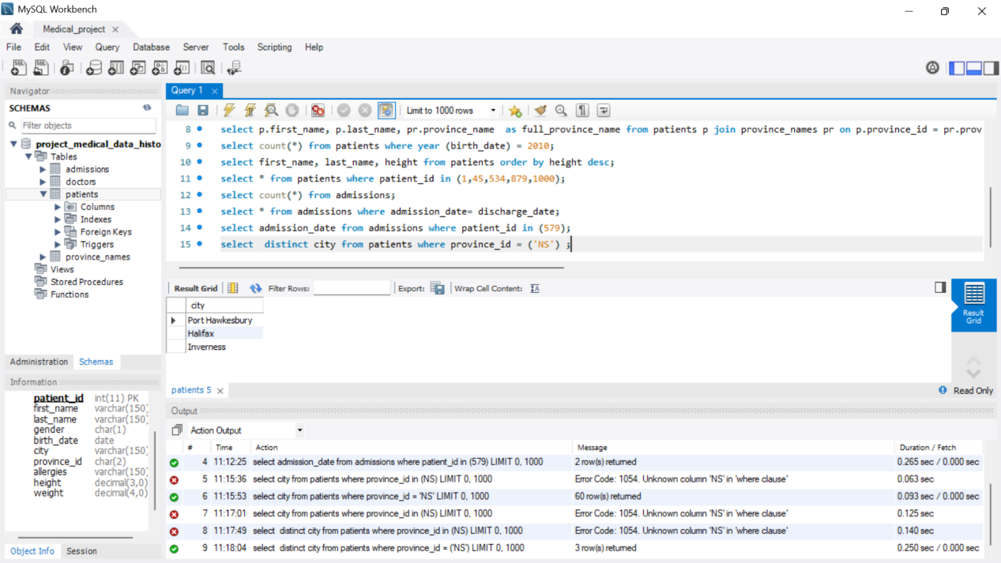

15. Write a query to find the first_name, last name and birth date of patients

who have height more than 160 and weight more than 70.

select first_name, last_name, birth_date from patients where height > 160 and weight > 70;

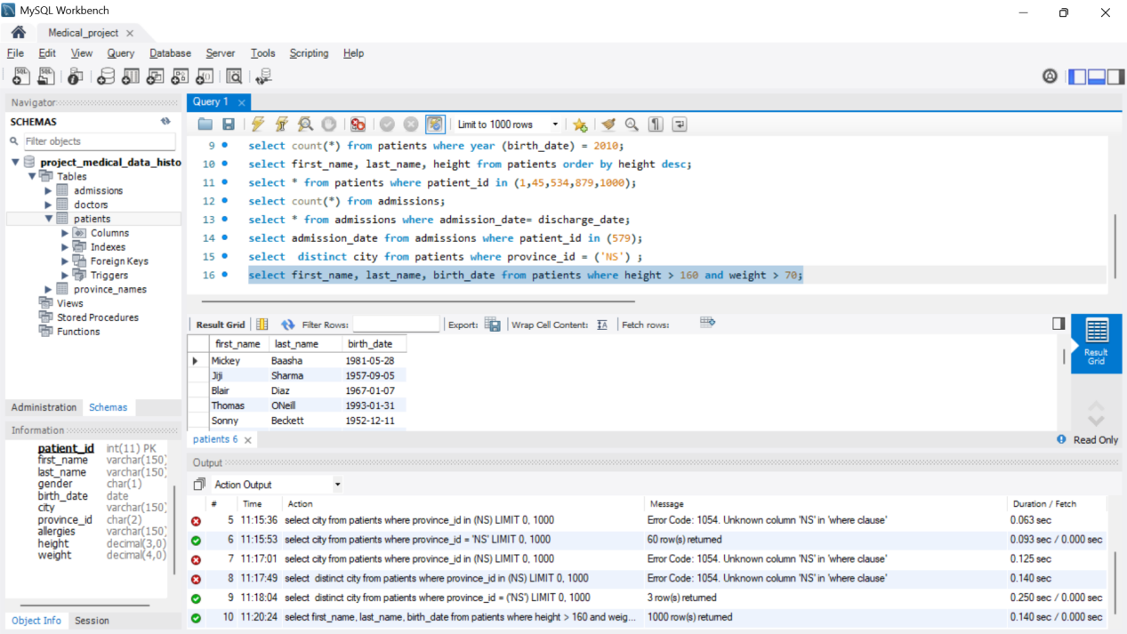

1. Show unique birth years from patients and order them by ascending.

select distinct year (birth_date) as birth_year from patients order by birth_year asc;

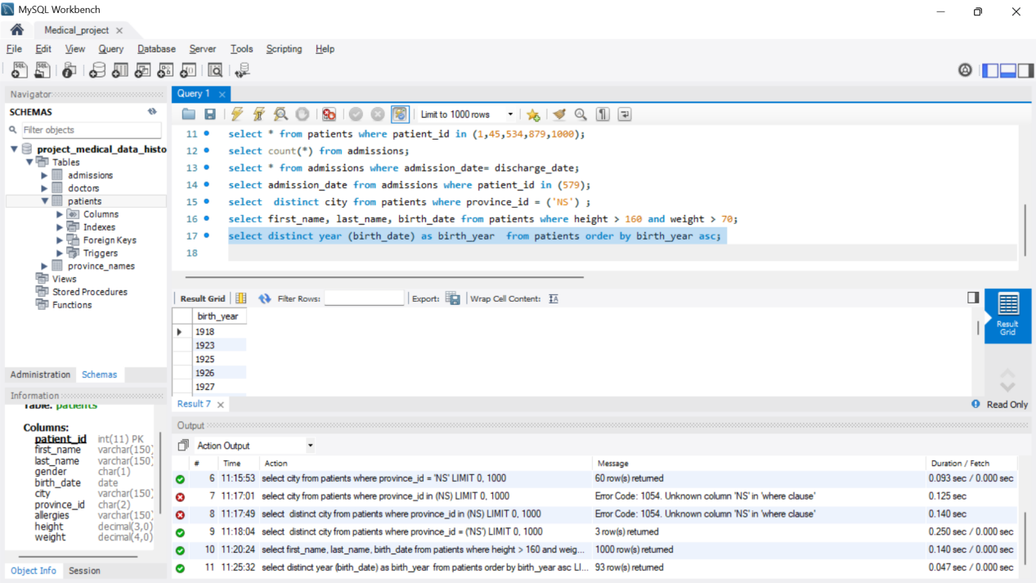

17. Show unique first names from the patients table which only occurs once in

the list.

select first_name from patients group by first_name having count(*)=1 ;

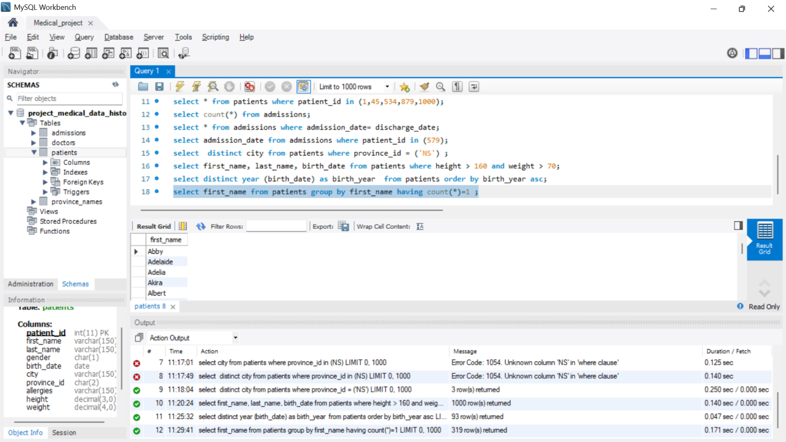

18. Show patient_id and first_name from patients where their first_name starts

and ends with 's' and is at least 6 characters long.

select patient_id, first_name from patients where first_name like 's%s' and length( first_name >=6);

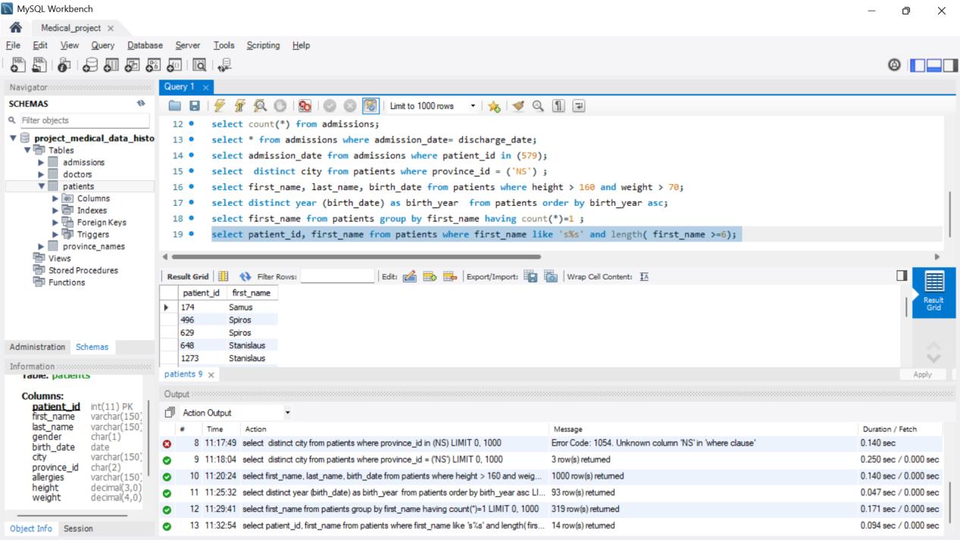

19. Show patient_id, first_name, last_name from patients whose diagnosis is

'Dementia'. Primary diagnosis is stored in the admissions table.

select p.patient_id, p.first_name, p.last_name from patients p join admissions a on p.patient_id = a.patient_id where a.diagnosis = 'Dementia';

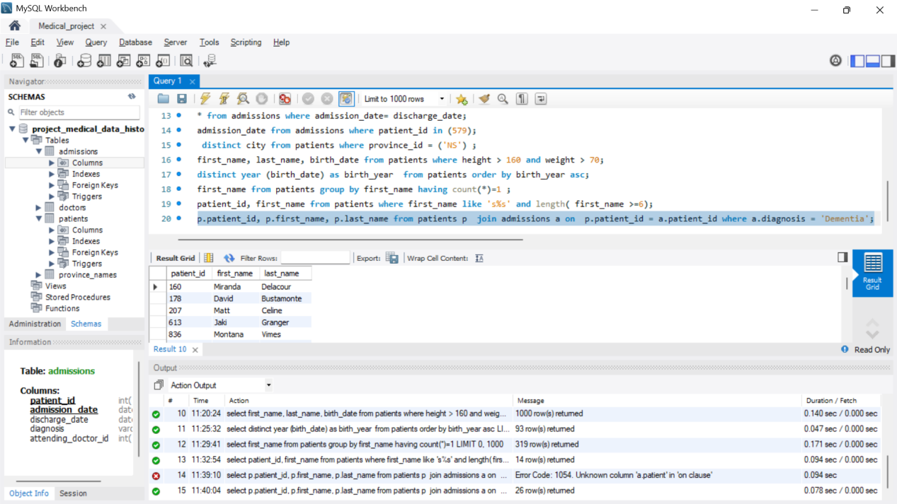

20. Display every patient's first_name. Order the list by the length of each

name and then by alphabetically.

select first_name from patients order by length(first_name),first_name;

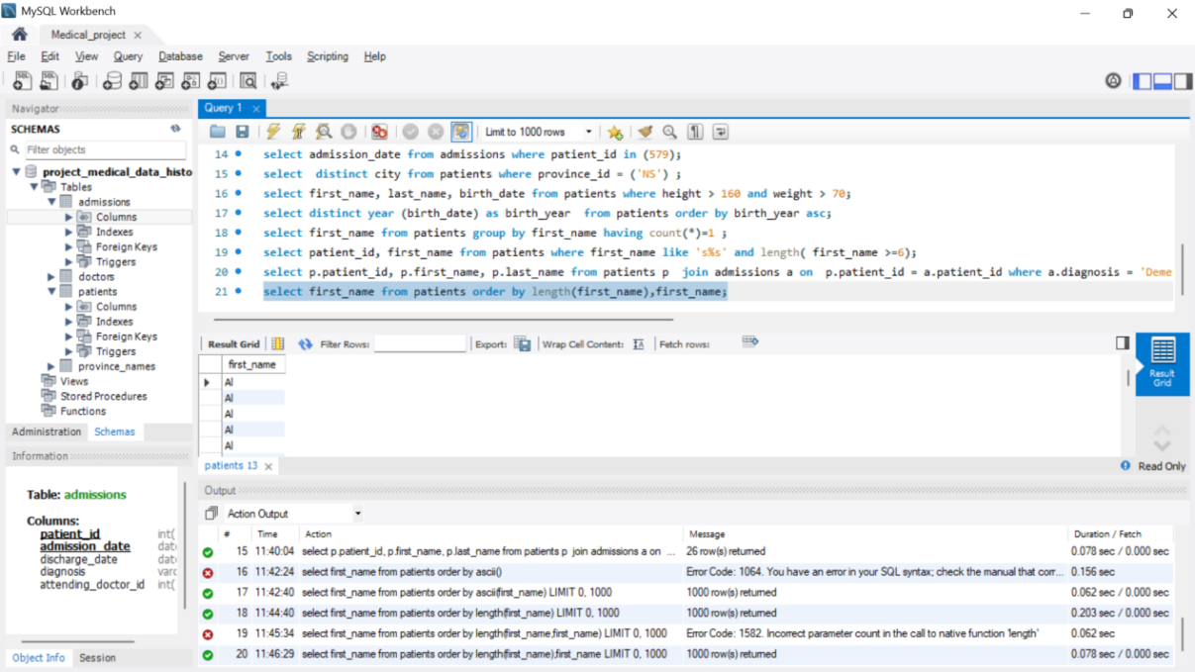

**DAY-5**

**Performed 21 to 30 queries.**

21 and 22. Show the total number of male patients and the total number of female

patients in the patients table. Display the two results in the same row.

Select (select count(*) from patients where gender = 'M') as total_male,

(select count(*) from patients where gender = 'F') as total_female;

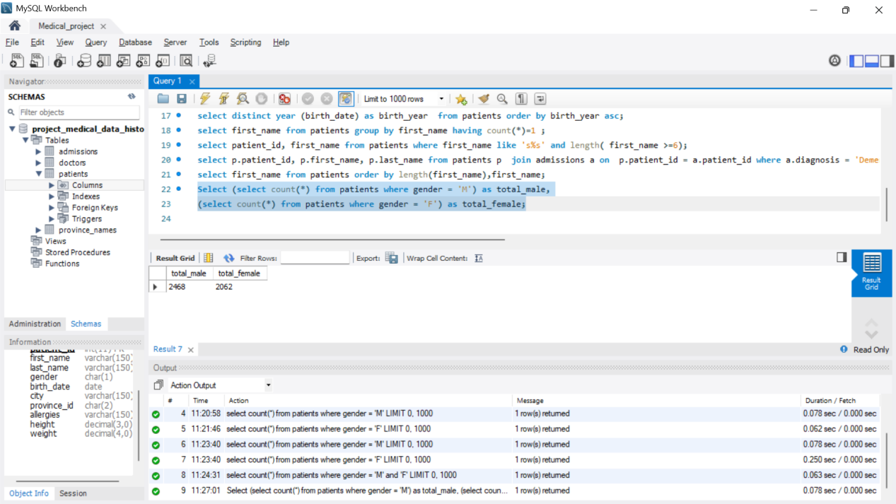

23. Show patient_id, diagnosis from admissions. Find patients admitted

multiple times for the same diagnosis.

select city, diagnosis from admissions group by patient_id, diagnosis having count(*) > 1;

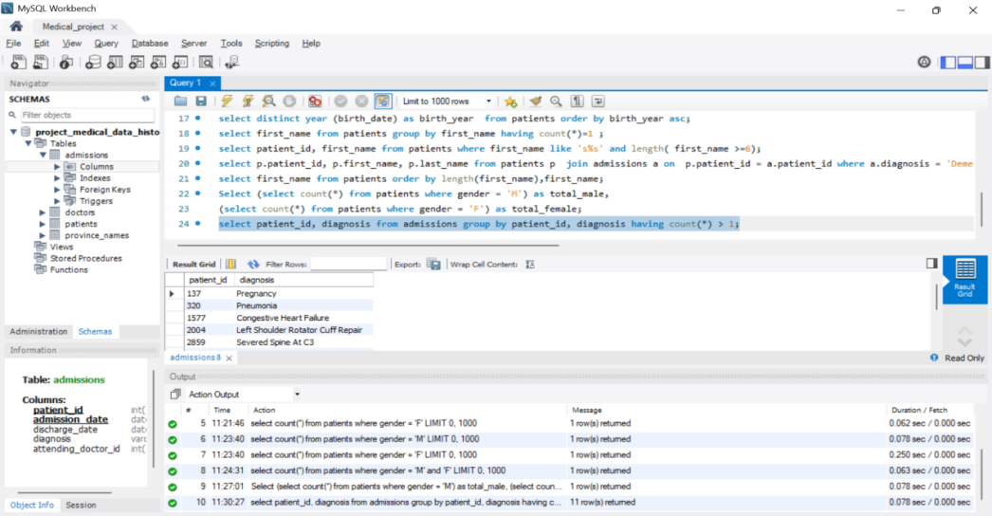

24. Show the city and the total number of patients in the city. Order from most

to least patients and then by city name ascending.

select city, count(*) as total_patients from patients group by city order by total_patients desc, city asc;

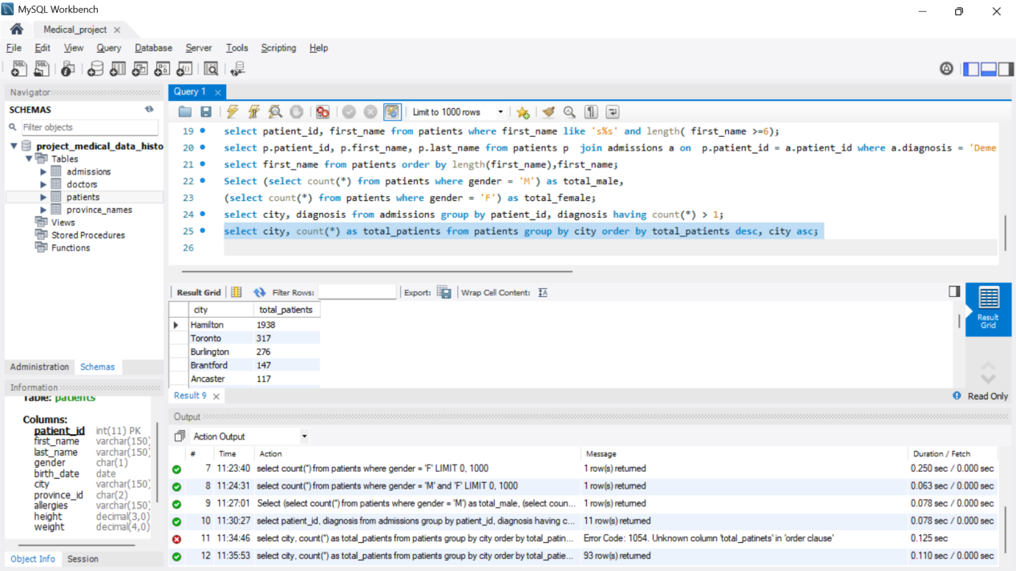

25. Show first name, last name and role of every person that is either patient

or doctor. The roles are either "Patient" or "Doctor".

select first_name, last_name , 'patient' as role from patients union select first_name, last_name, 'Doctor' as role from doctors;

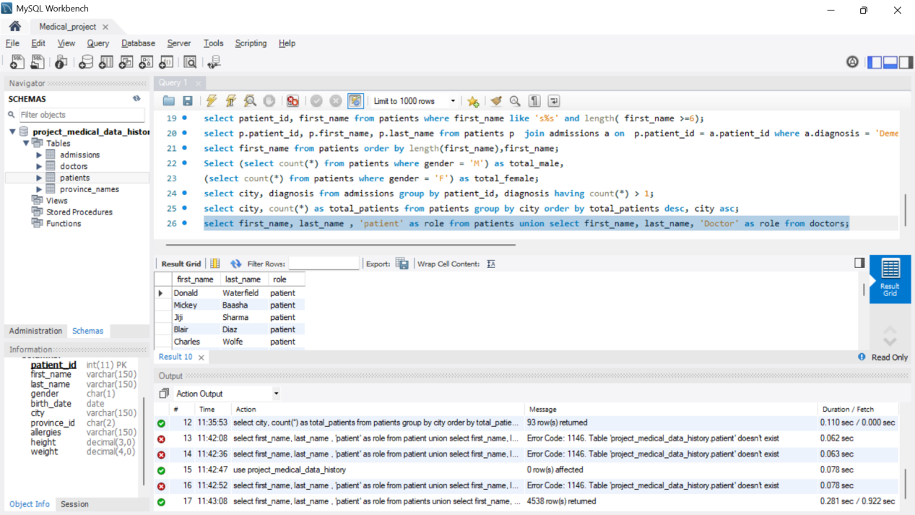

26. Show all allergies ordered by popularity. Remove NULL values from the

query.

select allergies, count(*) as popularity from patients where allergies is not null group by allergies order by popularity desc;

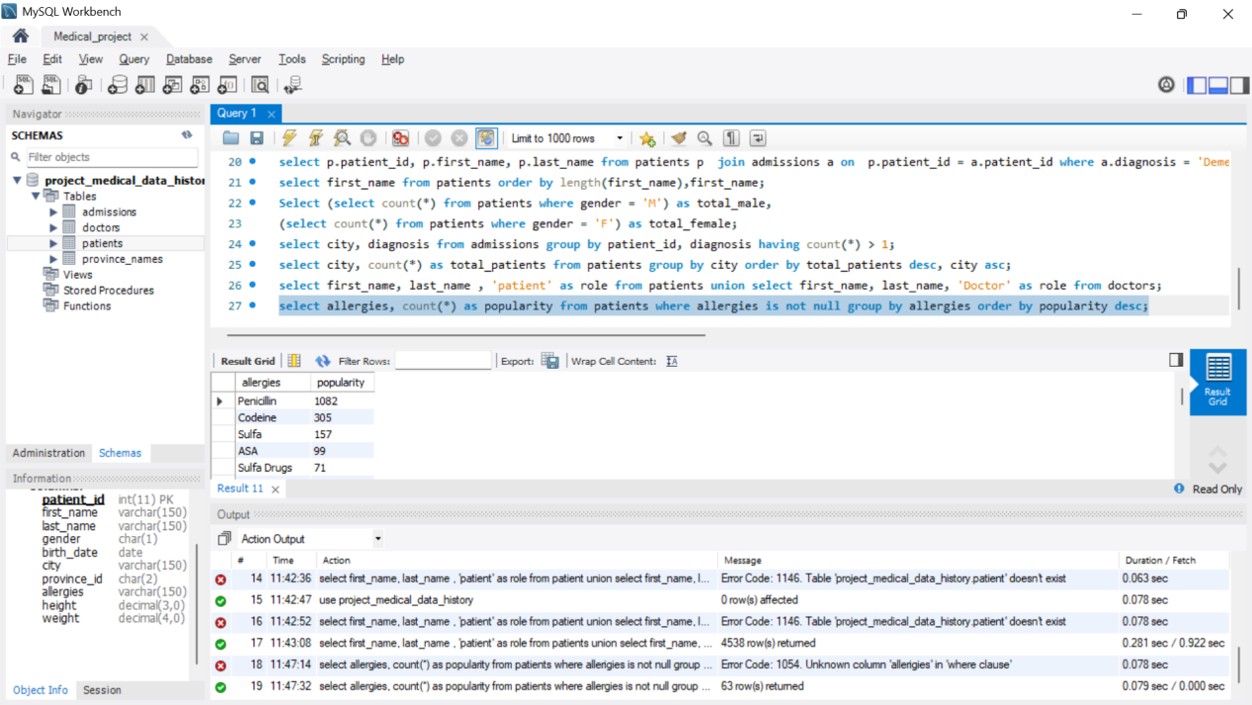

27. Show all patient's first_name, last_name, and birth_date who were born in

the 1970s decade. Sort the list starting from the earliest birth_date.

select first_name, last_name, birth_date from patients where year(birth_date) between 1970 and 1979 order by birth_date asc;

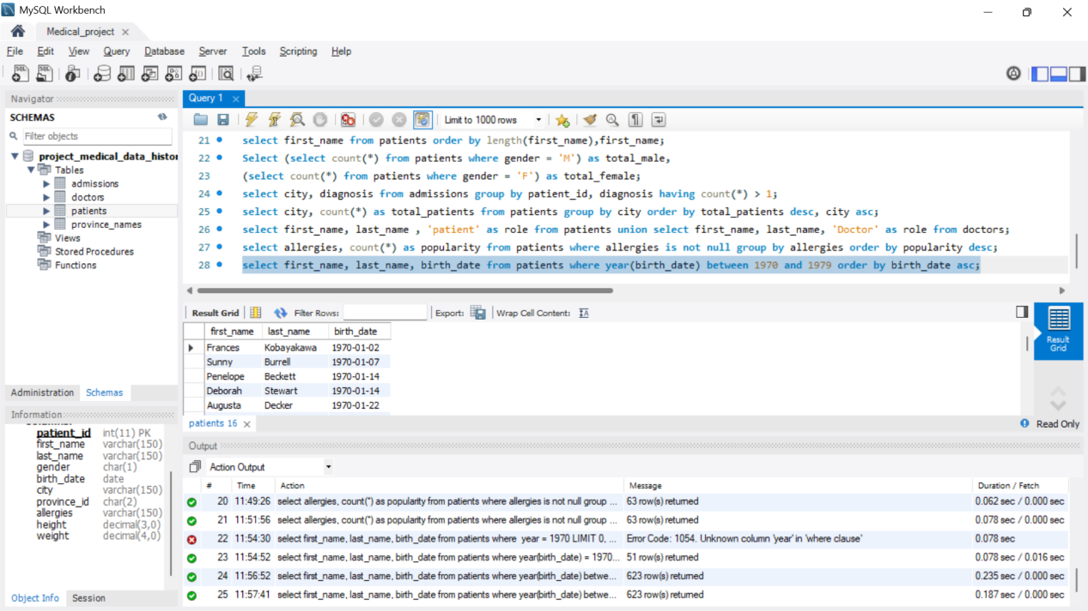

28. We want to display each patient's full name in a single column. Their

last_name in all upper letters must appear first, then first_name in all lower

case letters. Separate the last_name and first_name with a comma. Order the

list by the first_name in descending order EX: SMITH,jane.

select concat( upper(last_name) ,',' , lower(first_name) ) as full_name from patients order by first_name desc;

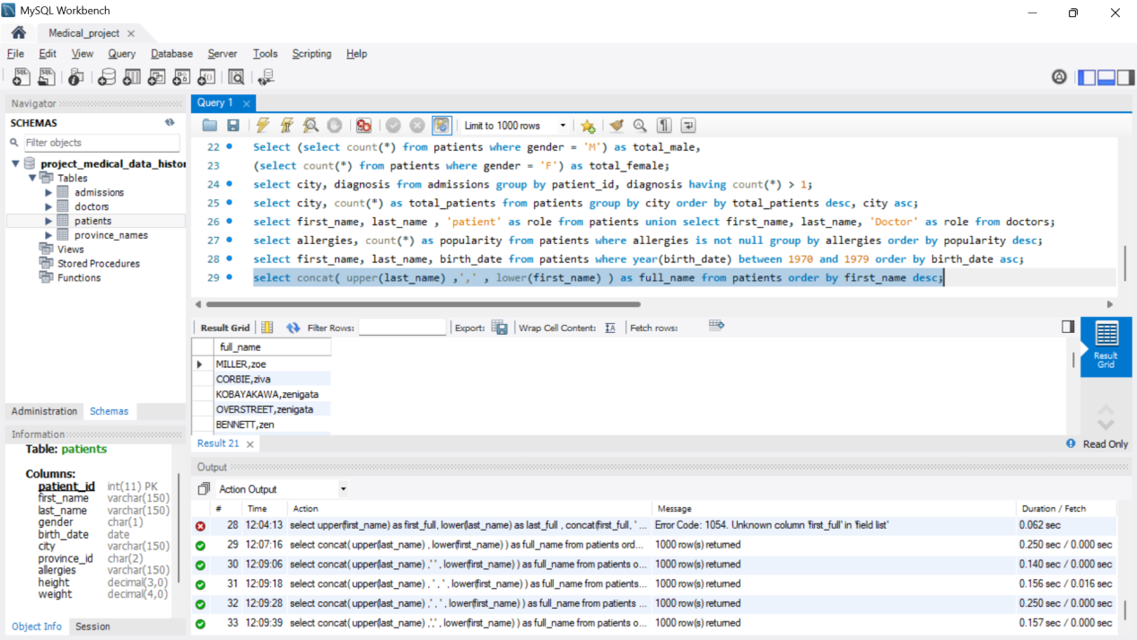

29. Show the province_id(s), sum of height; where the total sum of its patient's

height is greater than or equal to 7,000.

select province_id, sum(height) as total_height from patients group by province_id having total_height >= 7000 ;

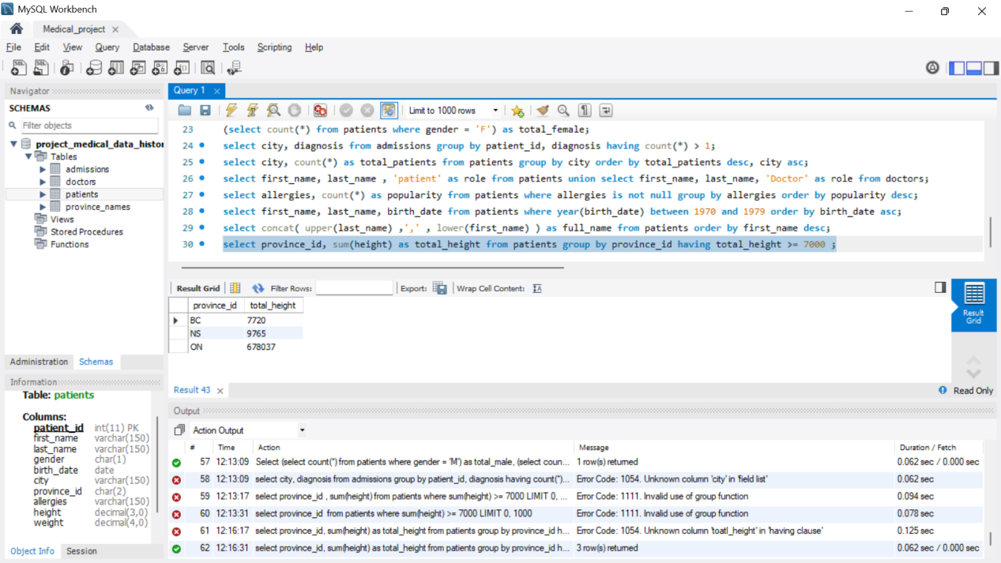

30. Show the difference between the largest weight and smallest weight for

patients with the last name 'Maroni'.

select max(weight) - min(weight) as weight_differnce from patients where last_name = 'Maroni';

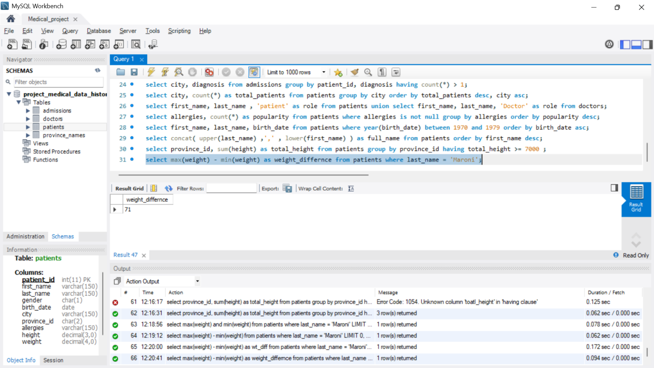

**DAY 6**

**Performed 31 to 35 queries.**

31. Show all of the days of the month (1-31) and how many admission_dates

occurred on that day. Sort by the day with most admissions to least

admissions.

select day(admission_date) as day_of_month, count(*) as total_admissions from admissions group by day_of_month order by total_admissions desc;

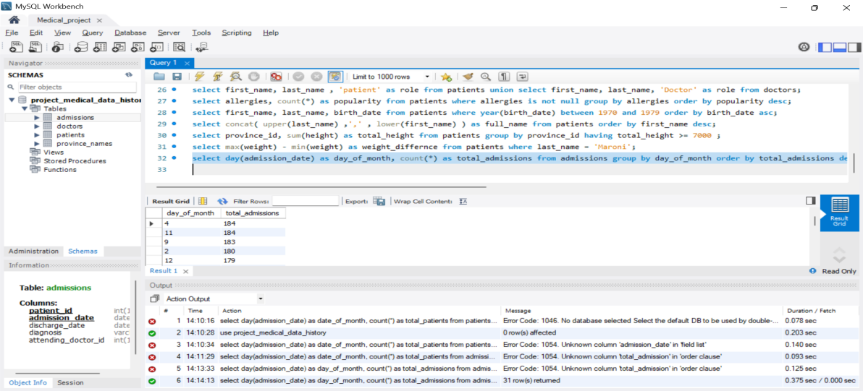

32. Show all of the patients grouped into weight groups. Show the total

number of patients in each weight group. Order the list by the weight group

descending. e.g. if they weigh 100 to 109 they are placed in the 100 weight

group, 110-119 = 110 weight group, etc.

select (weight div 10) * 10 as weight_group, count(*) as total_patients from patients weight_group group by weight_group order by weight_group desc;

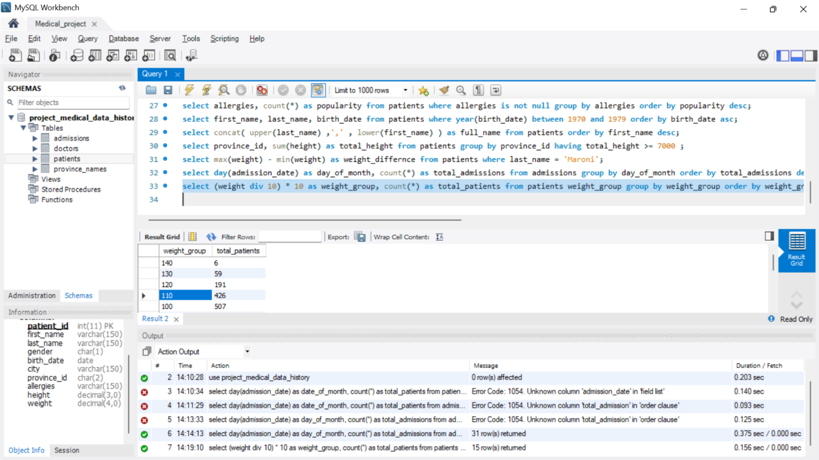

33. Show patient_id, weight, height, isObese from the patients table. Display

isObese as a boolean 0 or 1. Obese is defined as weight(kg)/(height(m).

Weight is in units kg. Height is in units cm.

select patient_id, weight, height, weight / power(height/100, 2) >= 30 as isObese from patients;

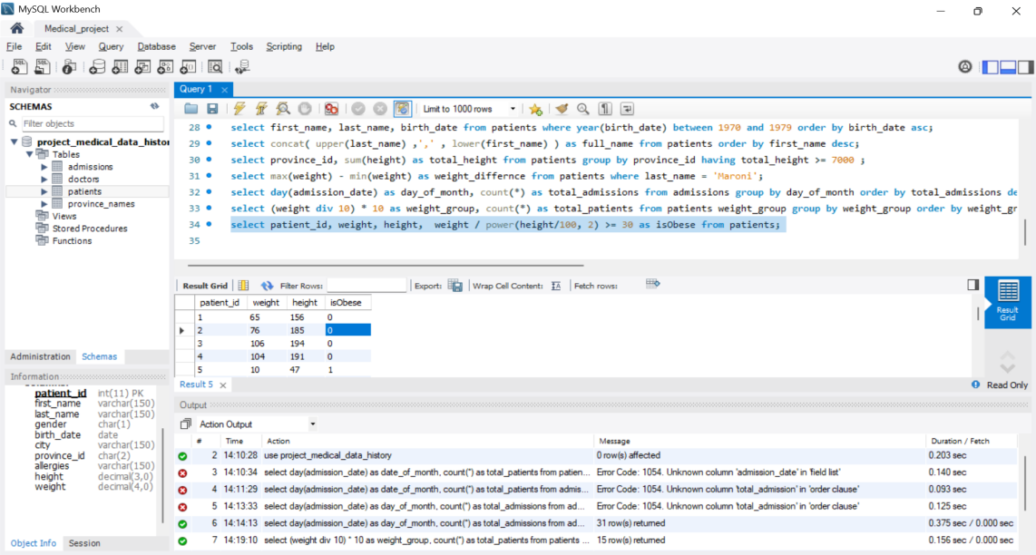

34. Show patient_id, first_name, last_name, and attending doctor's specialty.

Show only the patients who has a diagnosis as 'Epilepsy' and the doctor's first

name is 'Lisa'. Check patients, admissions, and doctors tables for required

information.

select p.patient_id,p.first_name,p.last_name,d.specialty from patients p join admissions a on p.patient_id = a.patient_id join doctors d on a.attending_doctor_id = d.doctor_id where a.diagnosis = 'Epilepsy' and d.first_name = 'Lisa';

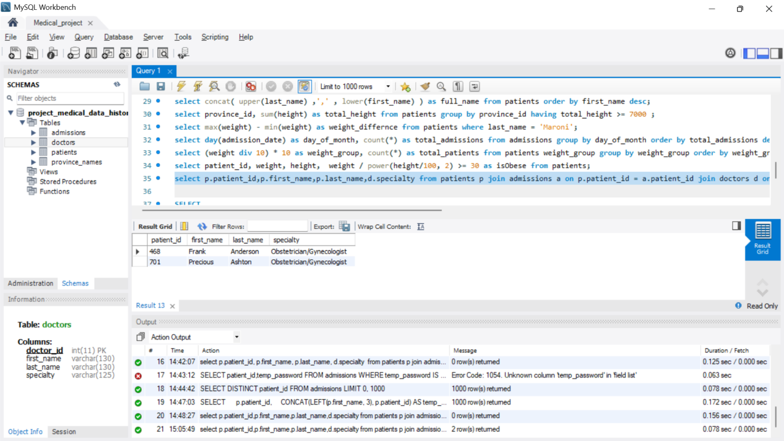

35. All patients who have gone through admissions, can see their medical

documents on our site. Those patients are given a temporary password after

their first admission. Show the patient_id and temp_password.

Select patient_id, concat(patient_id, length(last_name),year(birth_date)) as temp_password from patients;

